**Final Project**

**Michal Shuy, Or Asis, Naama Nigri, David Kalimi**

**Introduction**

Across the world, divorce has become an increasingly visible and complex social issue, one that reflects deeper questions about marital stability, shifting cultural values, and the changing structure of families. Prior studies¹ have linked divorce rates to factors such as financial hardship, age at marriage, education, and religious affiliation.

Building on this foundation, we chose to focus on Israel, not only because it is personally relevant to us as citizens, but because its internal diversity, religious, cultural, and demographic, makes it a uniquely rich case for exploring how social identity and family dynamics intersect. Although Israel’s divorce rate is close to the OECD average², the complexity of its population allows for a more nuanced examination of the factors that influence divorce beyond broad international comparisons.

To ensure our analysis reflects stable, long-term trends rather than short-term shocks, we chose 2019 as our reference year, prior to COVID-19 and recent geopolitical events, which are known to have significantly influenced divorce trends3.

Our general research question is: **What are the dominant predictors of divorce in Israel?** To answer this, we explored data on voting behavior, employment rates, age distribution, and ethnic composition across cities, using both correlation analysis and clustering techniques. This is also a challenging question to study. Marriage and divorce are deeply personal, often shaped by subjective and unmeasurable factors, which makes generalization difficult Our approach is to use clustering and statistical modeling to segment the Israeli population and uncover whether specific groups—sometimes assumed to be stable—are indeed less prone to divorce. This forms the groundwork for further insights revealed later in our report.

**Data Overview**

Our dataset contains demographic, socioeconomic, and cultural information for localities in Israel, all from the year 2019. The data was sourced from the official Israeli government data portal (gov.il) and includes 64 features, which we organize into three main feature families:

**- General City Data:** Includes variables related to population size, age group distribution, population growth/decline, and ethnic composition (e.g., Jews, Arabs, Others)

- **Socioeconomic Indicators:** Represents demographic characteristics of job seekers in each locality, offering insights into employment status and education levels—particularly the share of residents actively seeking work.

- **Cultural Proxies:** Represents cultural and religious identity through voting patterns in national elections. This includes both raw votes for individual parties (e.g., Shas, Meretz, Likud) and aggregated categories such as votes_haredi, votes_arab, and votes_other.

The **target** variable is divorces_sum, which reflects the number of divorces recorded in each city during 2019.

This structured categorization of features helps us explore meaningful correlations between demographic, economic, and cultural factors and divorce rates. By distinguishing these families, we aim to better identify patterns and understand the underlying drivers of divorce in Israeli society.

**Methods and Results**

The aim of this study was to explore the demographic and cultural factors that influence divorce rates across Israeli cities.

We began our investigation with a simple comparison between several well-known cities. Tel Aviv, Jerusalem, and Bnei Brak. We observed large differences in divorce rates, which appeared to align with each city’s social and cultural profile. For example, Tel Aviv, known for its secular and liberal character, showed relatively high divorce rates, while Bnei Brak, a predominantly ultra-Orthodox city, had extremely low rates.

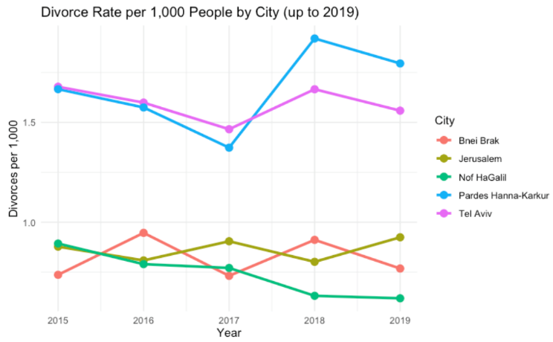To deepen the comparison, we added two more cities: Pardes Hanna-Karkur, another liberal and fast-growing community, and Nof HaGalil, a mixed city with both Jewish and Arab residents. While not a majority-Arab city, Nof HaGalil was selected as a proxy due to the lack of complete data on predominantly Arab municipalities in our dataset. Together, these five cities offered a meaningful snapshot of Israel’s social diversity and allowed us to begin examining how cultural composition might relate to family structure and divorce trends.

To evaluate whether cultural patterns observed in individual cities hold at a national scale, we used voting behavior as a proxy for a city’s dominant cultural identity. We examined multiple voting categories on the *Left–Right Spectrum* to identify patterns associated with divorce rates. Party affiliations were classified based on the composition of the 22nd Knesset4. Among all these, the most distinct differences emerged in cities with high support for ultra-Orthodox (Haredi) parties and Arab parties.

As shown in Figure 2, the boxplots demonstrate that cities with stronger religious voting profiles consistently exhibited lower divorce rates, whereas more secular or culturally mixed cities tended to report higher divorce rates.

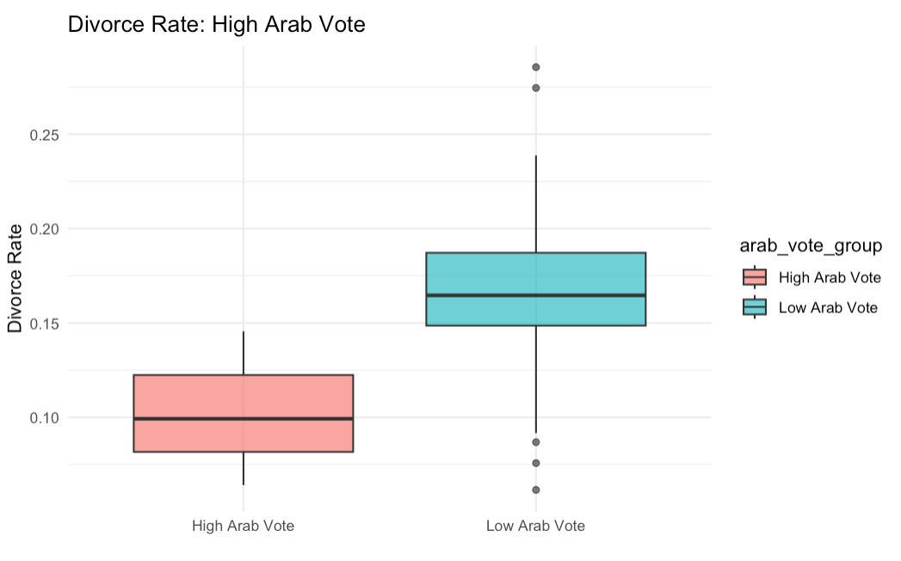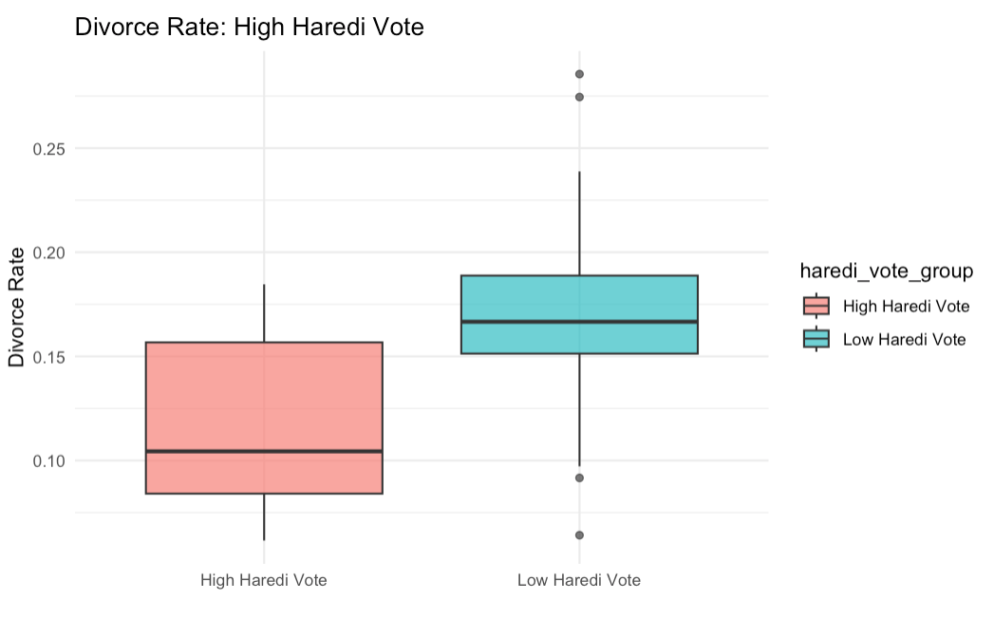

These patterns are not unique to Israel. A demographic study from the U.S. found that “highly religious couples are less likely to dissolve their marriage than less religious couples” and that “living in a more religious municipality further reduces divorce risk”5. This suggests that both personal beliefs and the social context of religious communities play a role in stabilizing marriage.

To deepen our understanding of the factors influencing divorce rates across Israeli cities, we moved beyond voting patterns and turned our attention to broader cultural identity. Our earlier findings revealed stark contrasts between cities with high support for Arab and ultra-Orthodox parties, suggesting that cultural divisions, particularly between Arab communities and the rest of the population, might underlie deeper societal patterns.

To explore this, we selected 30 cities whose total populations were closest to the national median, avoiding distortions from very large or very small cities. We then applied k-means clustering using just two variables: the proportion of Arab and Jewish residents in each city.

This clustering approach yielded strong internal consistency and well-separated groups, as indicated by a high average silhouette score (0.79), a strong pseudo R² (0.96), and low Davies-Bouldin index (0.30).

Although the clustering was based solely on ethnic composition, the resulting clusters showed consistent differences in additional variables, including divorce rates, average age, job-seeker rates, and children rate in the locality, underscoring broader structural divides.

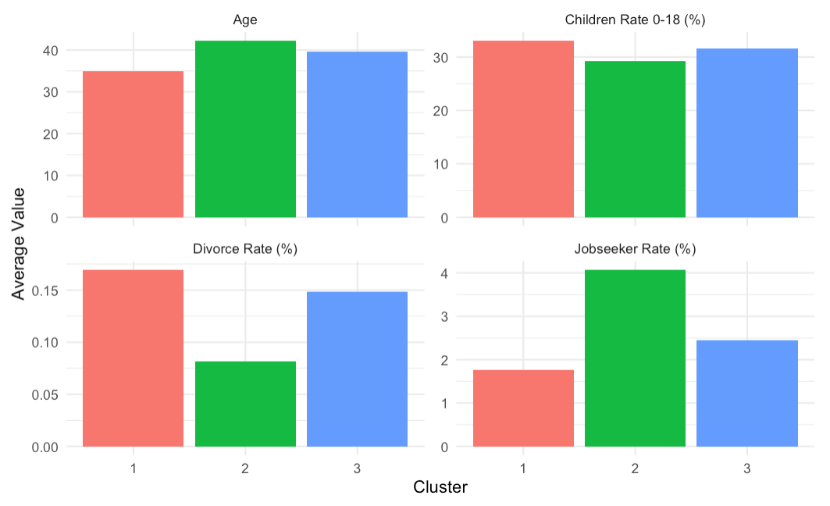**1– Predominantly Jewish (≈0–1% Arab)**

Highest divorce rate (≈ 0.17%), younger population (≈ 35), lower jobseeker rate.

**2 – High Arab Minority (≈ 25% Arab):**

Lowest divorce rate (≈ 0.82%), oldest population (≈ 42.2), highest jobseeker rate.

**3 – Low Arab Minority (≈ 1–10% Arab):**

Moderate divorce rate (≈ 0.15%), average age (≈ 39.7), mid jobseeker rate.

The findings we presented led us to consider that divorce rates might not depend solely on cultural identity, but could also stem from a broader range of demographic factors. We wanted to explore whether consistent patterns could be identified through variables such as average age, job seeker rate, or the proportion of children in the population. We attempted to re-cluster cities based on these variables, examined correlations, and even combined indicators. Yet no clear or meaningful segmentation emerged. Correlation analysis reinforced this outcome: key demographic variables such as the proportion of children (r = –0.102), job-seeker rate (r = –0.231), and average age (r = –0.131) showed only weak associations with divorce rates. This cautiously suggests that cultural identity may remain the most dominant and consistent factor—at least within the scope of the data available to us.

**Limitations and Future Work**

While our analysis provides meaningful insights into the predictors of divorce in Israel, several limitations must be acknowledged. The data is limited to 2019, preventing examination of long-term trends or recent events. Our use of voting patterns as a proxy for cultural identity may oversimplify internal diversity within cities. Additionally, divorce rates may be underreported in certain communities, particularly Arab and ultra-Orthodox, due to cultural stigma or alternative legal practices. Finally, relying on municipal-level data restricts our ability to account for individual or household-level factors.

If we had one additional month, we would focus on collecting more detailed data about the couples themselves, recognizing that city-level generalizations may overlook more personal or nuanced factors. This could include reaching out to divorce lawyers or legal aid organizations to access anonymized data on common causes of divorce, such as emotional distance, conflict, or cultural pressures.

With three additional months, we would aim to expand the dataset across multiple years and improve the reliability of demographic indicators, particularly for underrepresented populations, in order to better capture long-term patterns and deepen the demographic analysis.

Our code repository on Github: [https://github.com/NaamaNigri01/DivorceRatesProject](https://github.com/NaamaNigri01/DivorceRatesProject%20)

Link to our data folder:

<https://drive.google.com/drive/folders/1lDg3He8peEky0_dCqKqRCU_FWzsmPqsC>

**Appendix:**

1: [**Lawdin – Divorce Rates in Israel: Trends and Cause:**](https://lawdin.co.il/%D7%90%D7%97%D7%95%D7%96%D7%99-%D7%92%D7%99%D7%A8%D7%95%D7%A9%D7%99%D7%9F-%D7%91%D7%99%D7%A9%D7%A8%D7%90%D7%9C-%D7%9E%D7%92%D7%9E%D7%95%D7%AA-%D7%92%D7%95%D7%A8%D7%9E%D7%99%D7%9D-%D7%95%D7%94%D7%A9/)

An article summarizing divorce patterns in Israel, highlighting key contributing factors such as socioeconomic conditions, religious background, and age at marriage.

2:[**OECD – Marriage and Divorce Rates (2023):**](https://www.oecd.org/content/dam/oecd/en/data/datasets/family-database/sf_3_1_marriage_and_divorce_rates.pdf)

This dataset presents cross-country statistics on marriage and divorce rates in OECD member countries, allowing for international comparison of family trends.

3: [**Ynet – Divorce Trends During COVID-19 (Dayan-Wolfner, 2020):**](https://www.ynet.co.il/parents/article/SyQ00IRFaP)

Article discussing the rise in divorce rates in Israel during the pandemic.

[**Calcalist – Divorce Trends During Wartime (Sade, 2023):**](https://www.calcalist.co.il/local_news/article/s1lqogoba)

A news report focusing on the rise in divorce cases following recent conflicts in Israel.

4: [**Wikipedia – Party Distribution in the 22nd Knesset (2022):**](https://he.wikipedia.org/wiki/%D7%A7%D7%95%D7%91%D7%A5:%D7%94%D7%9B%D7%A0%D7%A1%D7%AA_%D7%94%D7%A2%D7%A9%D7%A8%D7%99%D7%9D_%D7%95%D7%A9%D7%AA%D7%99%D7%99%D7%9D.png)

A visual reference used to categorize political parties by ideology (e.g., religious, Arab, right, center).

5:[**Demographic Research – Rligion and Divorce in the US (**[**Vermeulen**](https://www.demographic-research.org/articles/articlesbyauthor/15510)**,** [**Zoutewelle-Terovan**](https://www.demographic-research.org/articles/articlesbyauthor/15511)**,** [**Kooiman**](https://www.demographic-research.org/articles/articlesbyauthor/14751)**,** [**Liefbroer**](https://www.demographic-research.org/articles/articlesbyauthor/978)**, 2023):**](https://www.demographic-research.org/articles/volume/49/20)

A study showing that higher religiosity among individuals and communities is associated with lower divorce rates.